Exercise 2: E-commerce Platform Search Function
1. Big O Notation
Big O Notation is used to measure the performance of an algorithm as the input size increases.
Common complexities:
- O(1) → Constant Time
- O(log n) → Logarithmic Time
- O(n) → Linear Time
- O(n²) → Quadratic Time
Search Scenarios
Case | Linear Search | Binary Search
Best Case | O(1) | O(1)
Average Case | O(n) | O(log n)
Worst Case | O(n) | O(log n)

Code :
using System;

class Product
{
public int ProductId;
public string ProductName;
public string Category;

public Product(int productId, string productName, string category)
{
ProductId = productId;
ProductName = productName;
Category = category;
}
}

class Program
{
static Product LinearSearch(Product[] products, int key)
{
foreach (Product product in products)
{
if (product.ProductId == key)
return product;
}
return null;
}

static Product BinarySearch(Product[] products, int key)
{
int low = 0, high = products.Length - 1;

while (low <= high)
{
int mid = (low + high) / 2;

if (products[mid].ProductId == key)
return products[mid];
else if (products[mid].ProductId < key)
low = mid + 1;
else
high = mid - 1;
}

return null;
}

static void Main(string[] args)
{
Product[] products =
{
new Product(101, "Laptop", "Electronics"),
new Product(102, "Mobile", "Electronics"),
new Product(103, "Shoes", "Fashion"),
new Product(104, "Watch", "Accessories"),
new Product(105, "Book", "Education")
};

int searchId = 104;

Product linearResult = LinearSearch(products, searchId);
if (linearResult != null)
Console.WriteLine("Linear Search Found: " + linearResult.ProductName);

Product binaryResult = BinarySearch(products, searchId);
if (binaryResult != null)
Console.WriteLine("Binary Search Found: " + binaryResult.ProductName);

Console.WriteLine("\nTime Complexity Analysis:");
Console.WriteLine("Linear Search - Best: O(1), Average: O(n), Worst: O(n)");
Console.WriteLine("Binary Search - Best: O(1), Average: O(log n), Worst: O(log n)");
Console.WriteLine("Binary Search is more suitable for large e-commerce platforms because it is much faster on sorted data.");
}
}
Output:
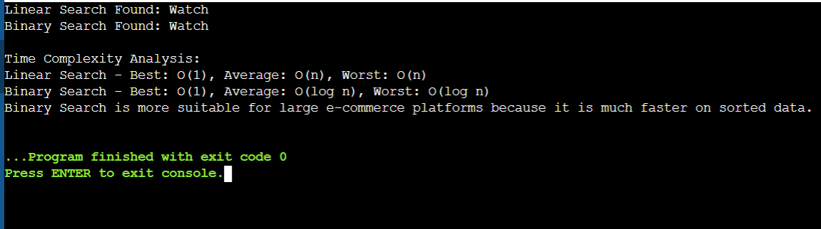

Exercise 7: Financial Forecasting
1. Understand Recursive Algorithms
What is Recursion?
Recursion is a programming technique in which a function calls itself to solve a problem by breaking it down into smaller subproblems. Every recursive function must have a base case that stops the recursion.
How does Recursion Simplify Problems?
- Reduces complex problems into smaller, manageable parts.
- Makes code shorter and easier to understand.
- Useful for mathematical calculations, tree traversal, searching, and forecasting.
2. Setup
Create a method to calculate future value using recursion.
Formula:
$$Future Value=Current Value×(1+Growth Rate)^{Years}$$
Recursive relation:
$$F(n)=F(n-1)×(1+GrowthRate)$$
Base Case:
$$F(0)=CurrentValue$$

CODE:
using System;

class Program
{
static double PredictFutureValue(double currentValue, double growthRate, int years)
{
if (years == 0)
return currentValue;

return PredictFutureValue(currentValue * (1 + growthRate), growthRate, years - 1);
}

static void Main(string[] args)
{
double currentValue = 10000;
double growthRate = 0.10;
int years = 5;

double futureValue = PredictFutureValue(currentValue, growthRate, years);

Console.WriteLine("Current Value: " + currentValue);
Console.WriteLine("Growth Rate: " + (growthRate * 100) + "%");
Console.WriteLine("Years: " + years);
Console.WriteLine("Predicted Future Value: " + futureValue);
}
}

OUTPUT:
